Why are humans capable of acquiring a large number of symbols, and what are the neural material features critical for this extraordinary ability? Here we will explore the material basis of symbols in the human brain by means of brain-inspired neural models constrained by cortical neuroanatomy, function and obeying well-established neuroscience principles (see figure). The subproject »exploring the material basis of symbols« aims to explain the cognitive activity (language, symbols, thought) by the structural features of the underlying neural matter present in the human brain, with the ultimate goal to generate brain simulator mimicking essential symbol processing functions with its application to specific healthy and patient brains.
Over and above neurocomputational simulations, neuroimaging and neuropsychological studies (using EEG, TMS, and/or fMRI) will be carried out to determine the neurobiological correlates of linguistic-conceptual and visual-gestalt-like symbolic processes in the human brain. Results will be compared with predictions generated by the neurocomputational model.
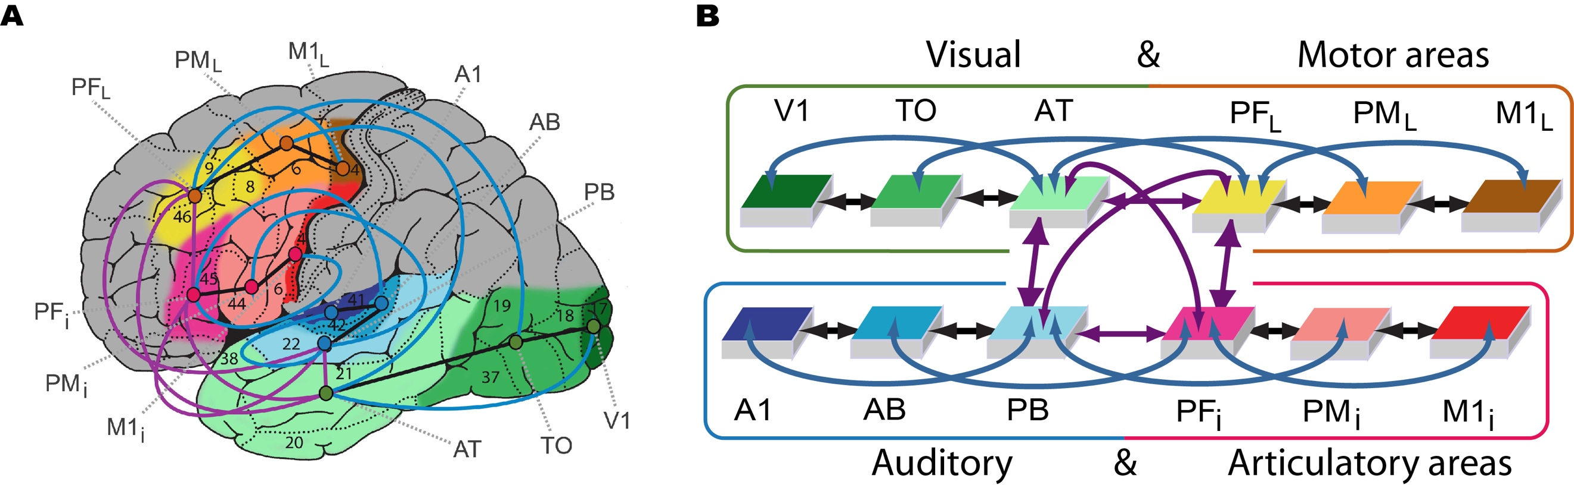
Model of lexical and semantic mechanisms. (A) Structure and connectivity of 12 frontal, temporal and occipital cortical areas relevant for learning the meaning of words related to objects and actions. (B) Schematic global area structure and connectivity of the implemented model constrained by neurobiological principles. Figure adapted from << Tomasello, R., et al. (2019). Visual cortex recruitment during language processing in blind individuals is explained by Hebbian learning. Scientific Reports, 9(1) >>

