Directions to the Brain Language Laboratory (BLL)

From the U-bahn station Dahlem Dorf (line U3)

- If you use the elevator, you are already at the intersection of Brümmerstraße/ Fabeckstraße. In case you use the stairs, walk back parallel to the platform until you reach the intersection.
- Follow Fabeckstraße for about 500m in a straight line and you will see a skyscraper to your left (pictured on the left).
- Opposite of the skyscraper, on the right side of the street, there is a way leading to the Rost-/Silberlaube entrance "Haupteingang K-Straße" (pictured on the right).
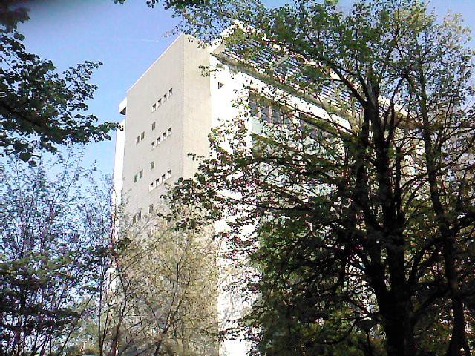
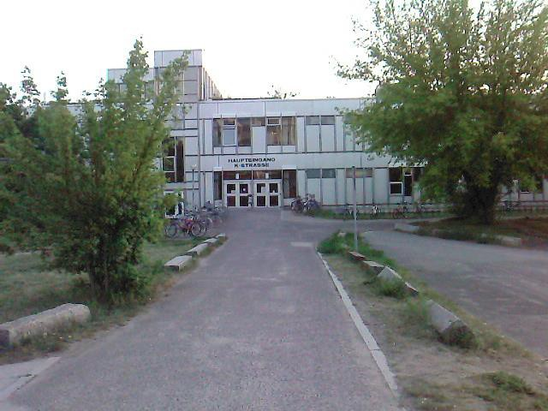

- Walk towards the entrance and take a left turn shortly before you reach it (pictured below).

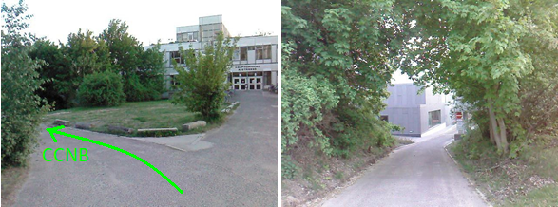
BLL

- Follow the way and you will see a grey building on your left. Keep following the street for about. The 6th door on the left “28. Straße JK Brain Language Laboratory – Labor für Gehirn und Sprachforschung” (pictured below) leads to the BLL. You will be picked up by a team member at the door in time for your appointment.
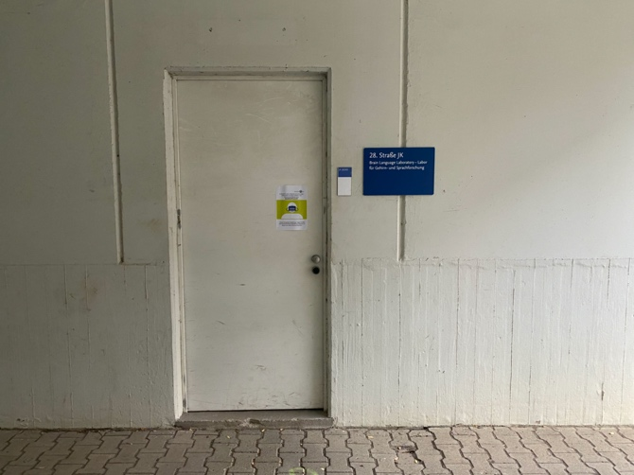
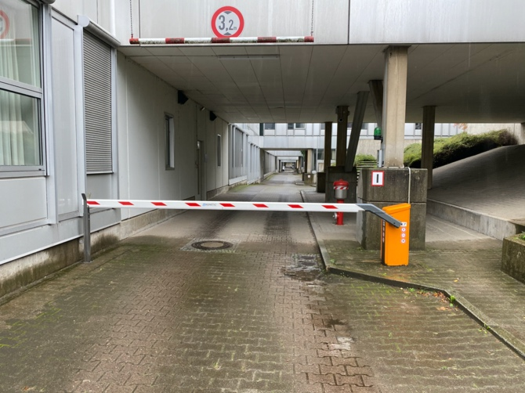

From the bus station Hittorfstraße (line M11)

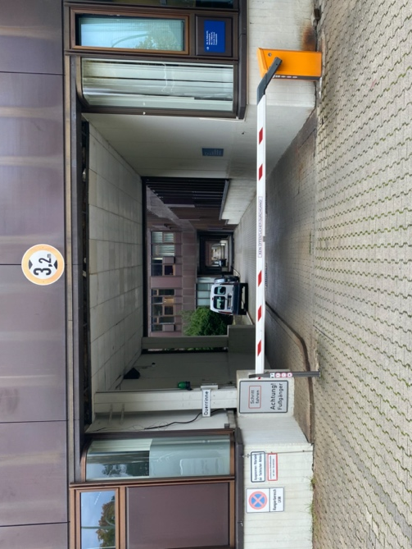
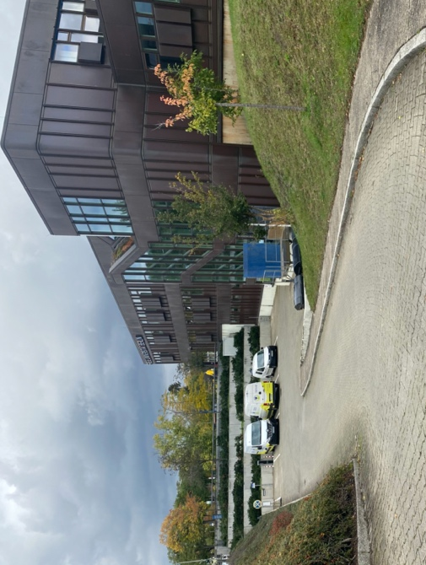
- If you exit at bus stop Hittorfstraße and turn towards the building of the Freie Universität you can already see the way, that leads to the Hauptpoststelle (the road is signposted). It’s to the right of the main entrance. Please follow the way.

- If you follow the way, the 4th door to the building on your right “28. Straße JK Brain Language Laboratory – Labor für Gehirn und Sprachforschung” (pictured in the description from U Dahlem Dorf) leads to the BLL. You will be picked up by a team member at the door in time for your appointment.

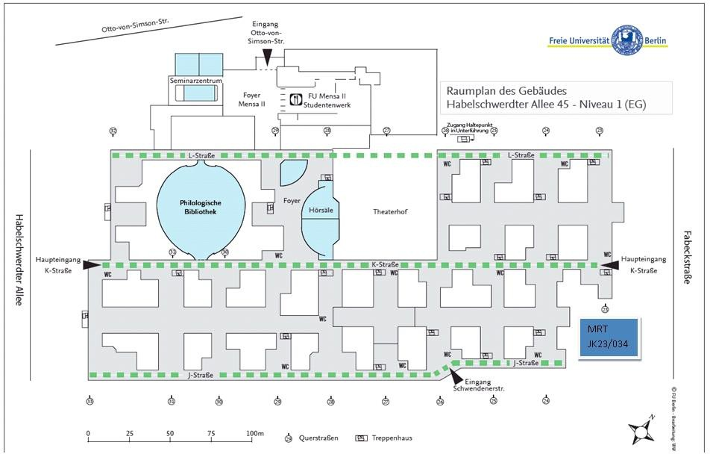
If you can't find the BLL, feel free to ask someone at the porter's lodge. There is one on either entrance described above.

